1. **Agenda**:
   1. How to publish event to a Kafka Topic synchronously.
2. 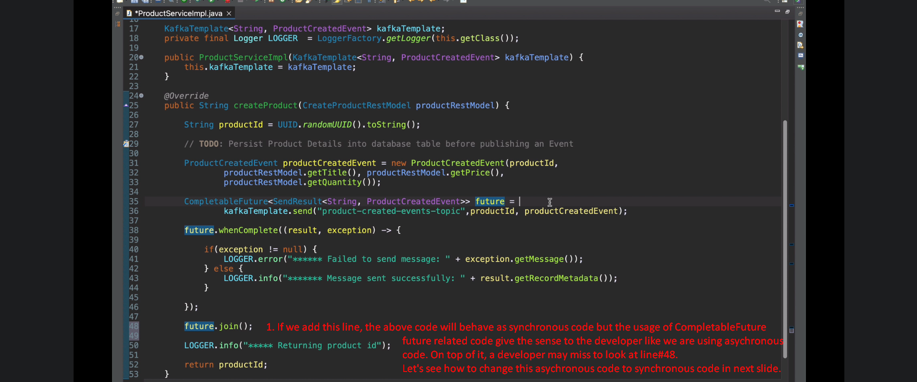
3. 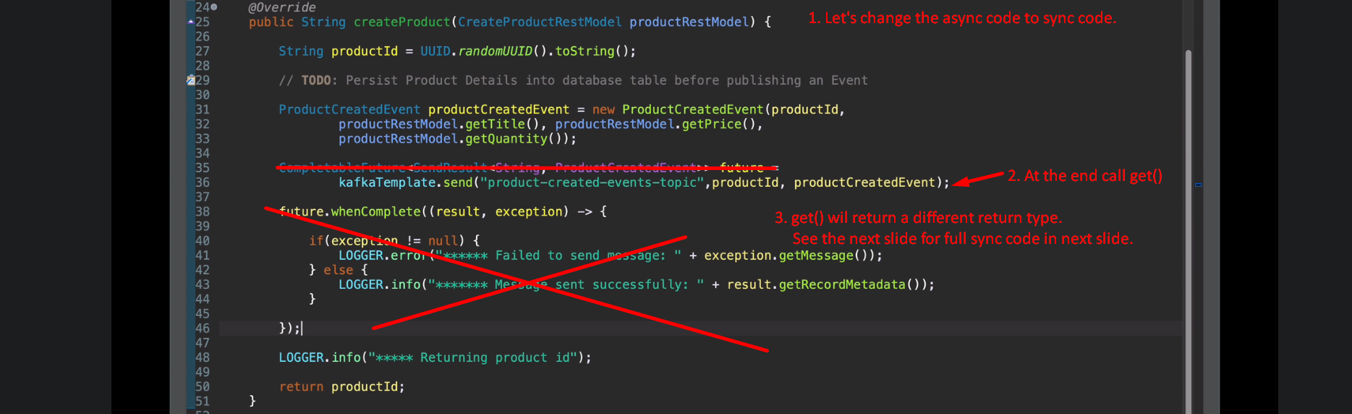
4. Following is the complete code to publishmsg synchronously. 